|  |  |
| --- | --- |
| The Wealth of Nations - Vero  Wealth of Nations  Assignment 1 Data Visualization | Alex Thompson  Date of Submission |

Table of Contents

• Table of Contents ............................................................................................................. 1

• Policies and Procedures.................................................................................................... 2-3

• Setting a Password ........................................................................................................... 4

• GDP Tasks 2, 3 and 4 ........................................................................................................ 5

• GDP Tasks 5 -10 …............................................................................................................. 6

• Tableau Charts 1 and 2 ..................................................................................................... 7

• Tableau Charts 3 and 4 ..................................................................................................... 8

• Tableau Dashboard and final summary ............................................................................ 9

**Data Management Policies**

Data management policies are the backbone of effective data governance. They ensure data is managed responsibly from creation to disposal. These policies set the standards for data handling, maintaining accuracy, security, and compliance with regulatory requirements.

**Direction and Support**

An organisation’s policies and procedures provide staff with enough direction to understand their roles and responsibilities regarding data protection and information governance.

Ways to meet expectations:

* A policy framework should stem from strategic business planning for data protection and information governance, which the highest level of management endorses.
* Policies should cover data protection, records management and information security.
* Operational procedures, guidance and manuals should be readily available to support data protection policies and provide direction to operational staff.
* Policies and procedures should clearly outline roles and responsibilities.

**Review and Approval**

Business’ must have a review and approval process in place to make sure that policies and procedures are consistent and effective.

Ways to meet expectations:

* All policies and procedures should follow an agreed format and style.
* An appropriately senior staff member should review and approve all new and existing policies and procedures.
* Existing policies and procedures should be reviewed in line with documented review dates, are up-to-date and fit for purpose.
* Policies and procedures should be updated without undue delay when they require changes, e.g. because of operational change, court or regulatory decisions or changes in regulatory guidance.
* All policies, procedures and guidelines should show document control information, including version number, owner, review date and change history.

**Staff Awareness**

Staff should be fully aware of the data protection and information governance policies and procedures that are relevant to their role.

Ways to meet expectations:

* Staff are able to read and understand the policies and procedures, including why they are important to implement and comply with.
* Staff are promptly informed about updated policies and procedures.
* Policies and procedures are made readily available for all staff on an organisation’s intranet site (or equivalent shared area) or are provided in other formats.
* Guidelines, posters or publications help to emphasise key messages and raise staff awareness of policies and procedures.

**Data protection by design and by default**

Policies and procedures foster a ‘data protection by design and by default’ approach across the organisation.

Ways to meet expectations:

* Where relevant, policies and procedures across the organization are considered with data protection in mind.
* Policies and procedures are present to ensure data protection issues are considered when systems, services, products and business practices involving personal data are designed and implemented, and that personal data is protected by default.
* An organisation’s approach to implementing the data protection principles and safeguarding individuals’ rights, such as data minimisation, pseudonymisation and purpose limitation, is set out in policies and procedures.
* The personal data of vulnerable groups, e.g. children, is given extra protection in policies and procedures.

**Why is this important for Data Analysts?**

As with any employee, data analysts are expected to follow the laws and regulations pertaining to data protection within their country of work. Likewise, their employer will also be keenly aware of the consequences of data loss, not only the legal ramifications but the risk to the business itself if confidential data such as financial records are acquired by competitors. As such, all employees, even those with limited access to company records will be expected to understand the rules and risks and will be required to complete data and privacy awareness courses on a yearly basis. This will be doubly true of any employees which work with confidential data, such as data analysts.

**Protecting an Excel File**

1. Click on ‘File’ in the top left corner:

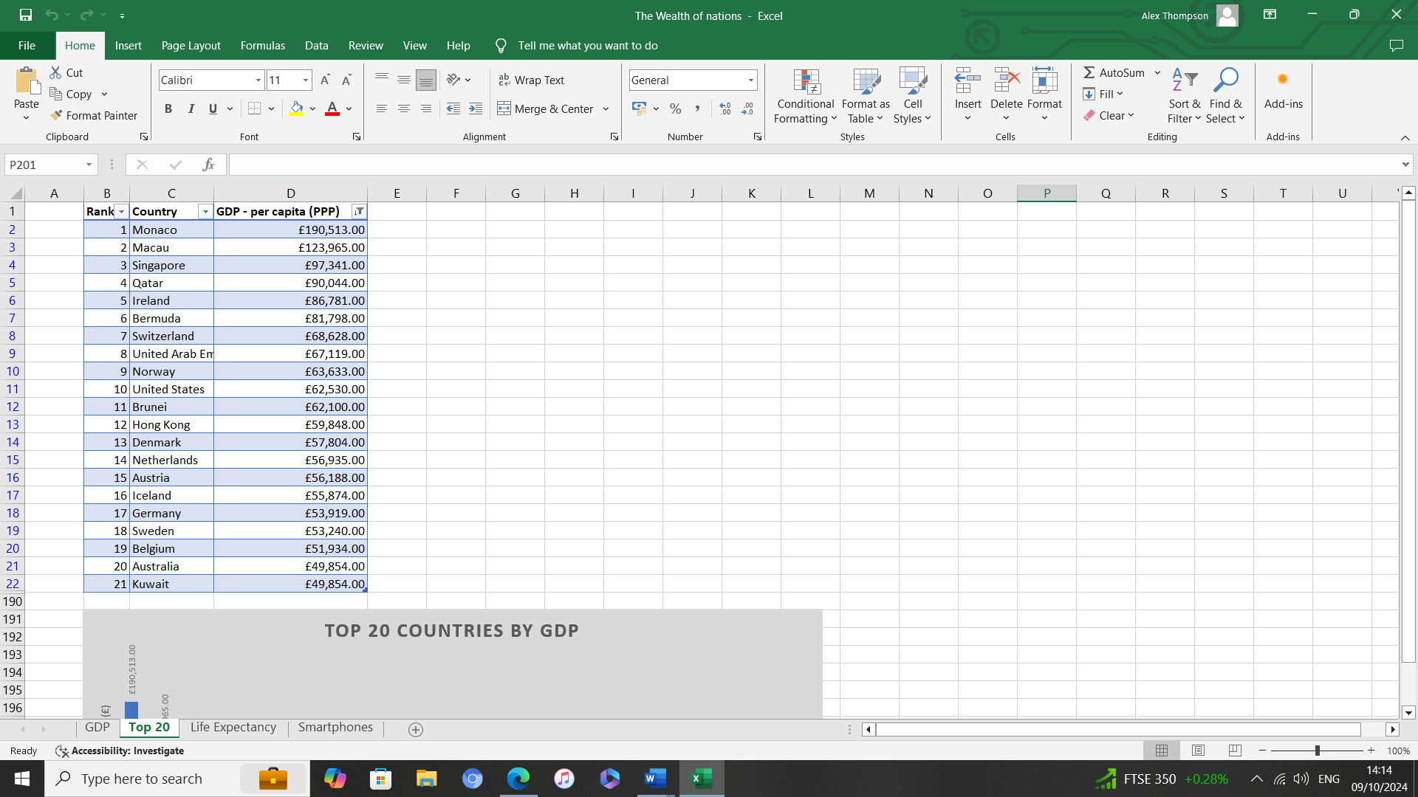

1. Click on ‘Info’ from the left-hand side menu:

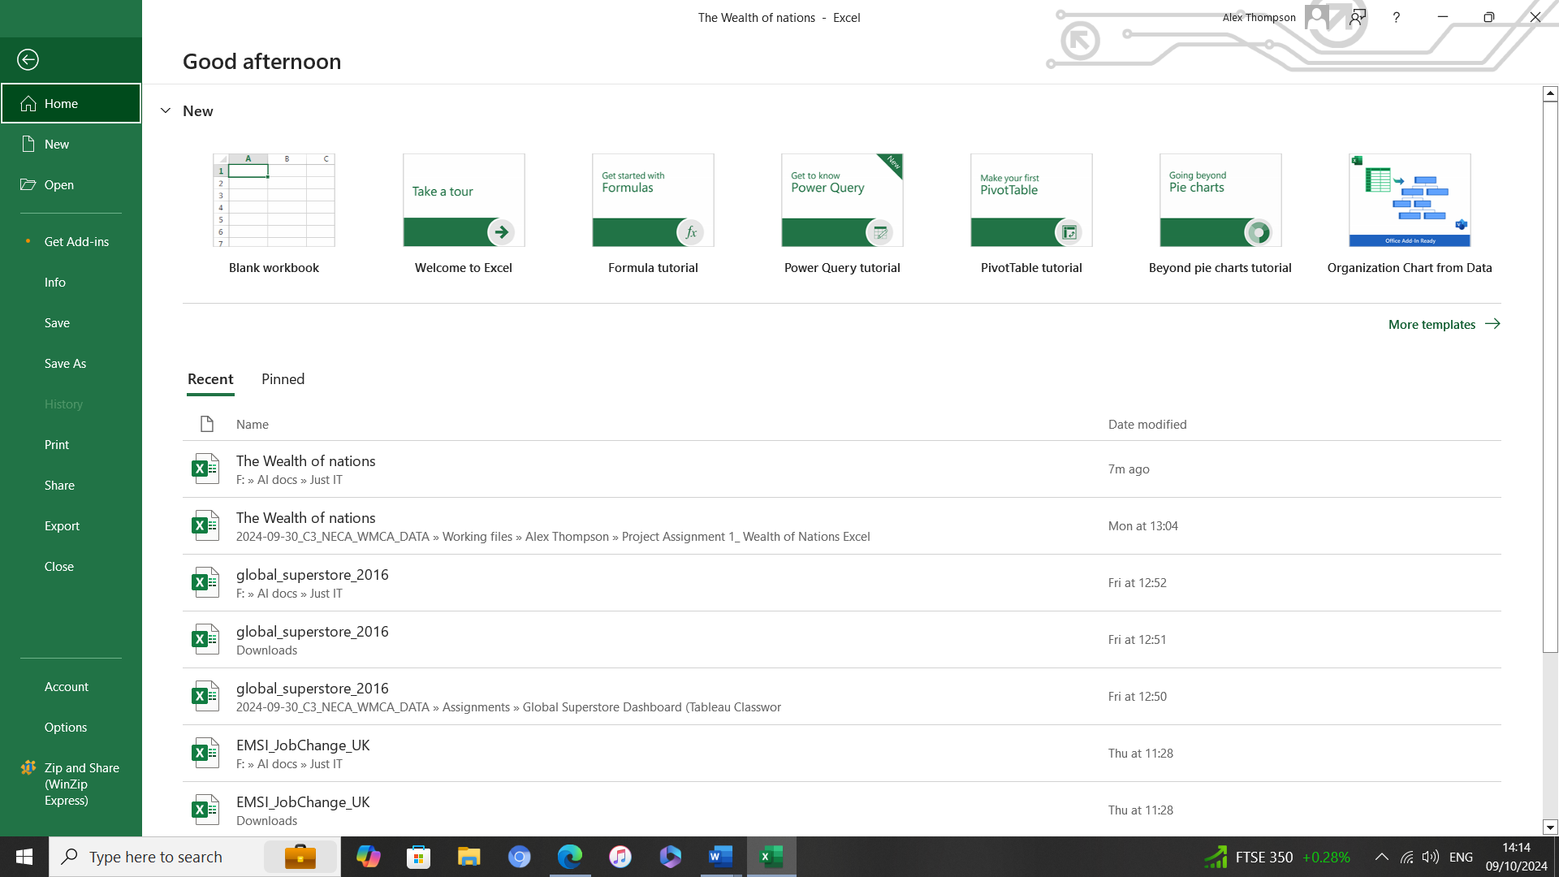

1. Click on ‘Protect Workbook’ drop down menu and select ‘Encrypt with Password’:

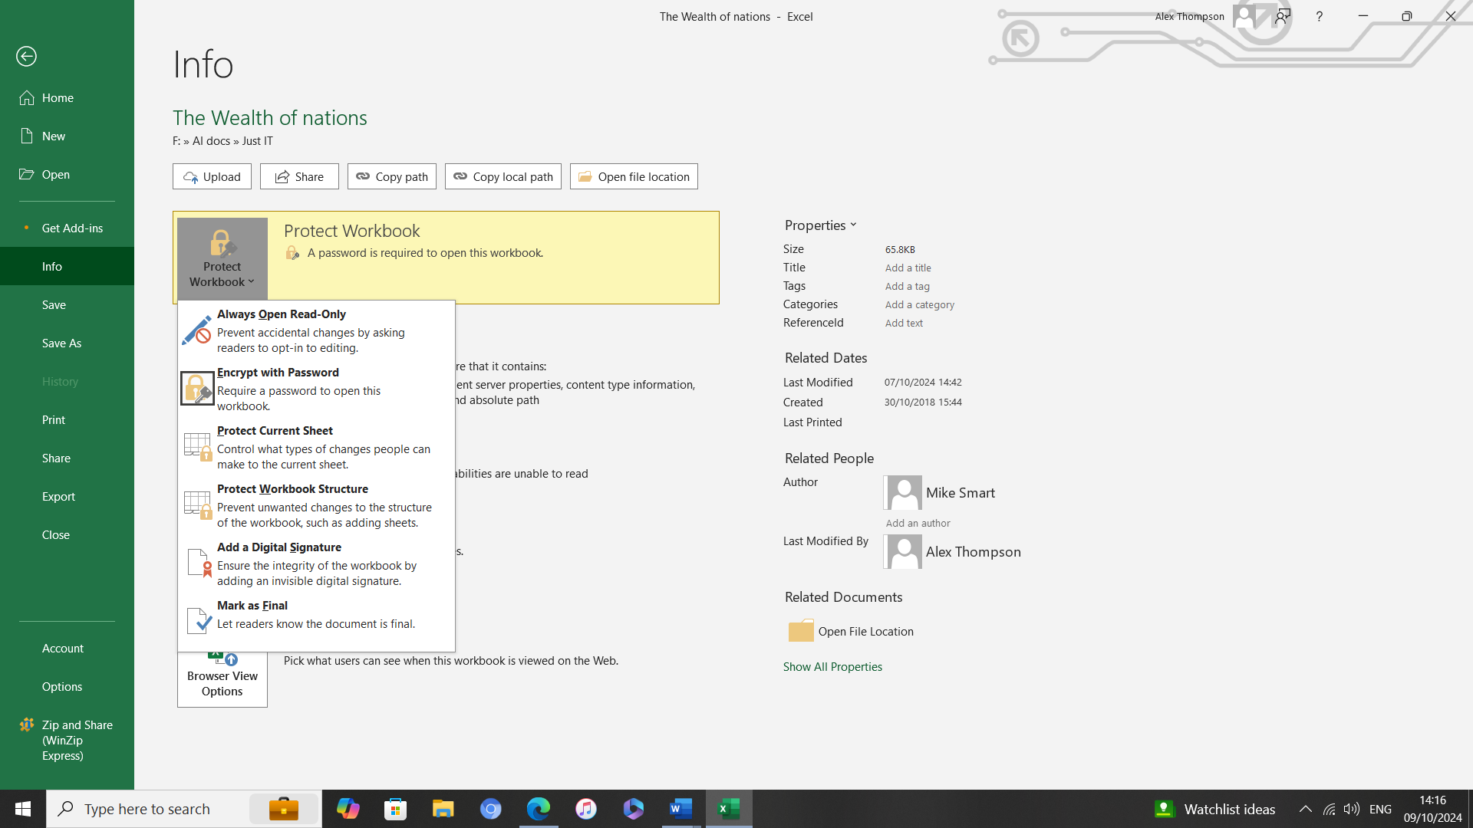

1. Choose a password and reenter to confirm (there are no minimum requirements with Excel passwords e.g. password length, use of numbers, capitals, special characters etc.):

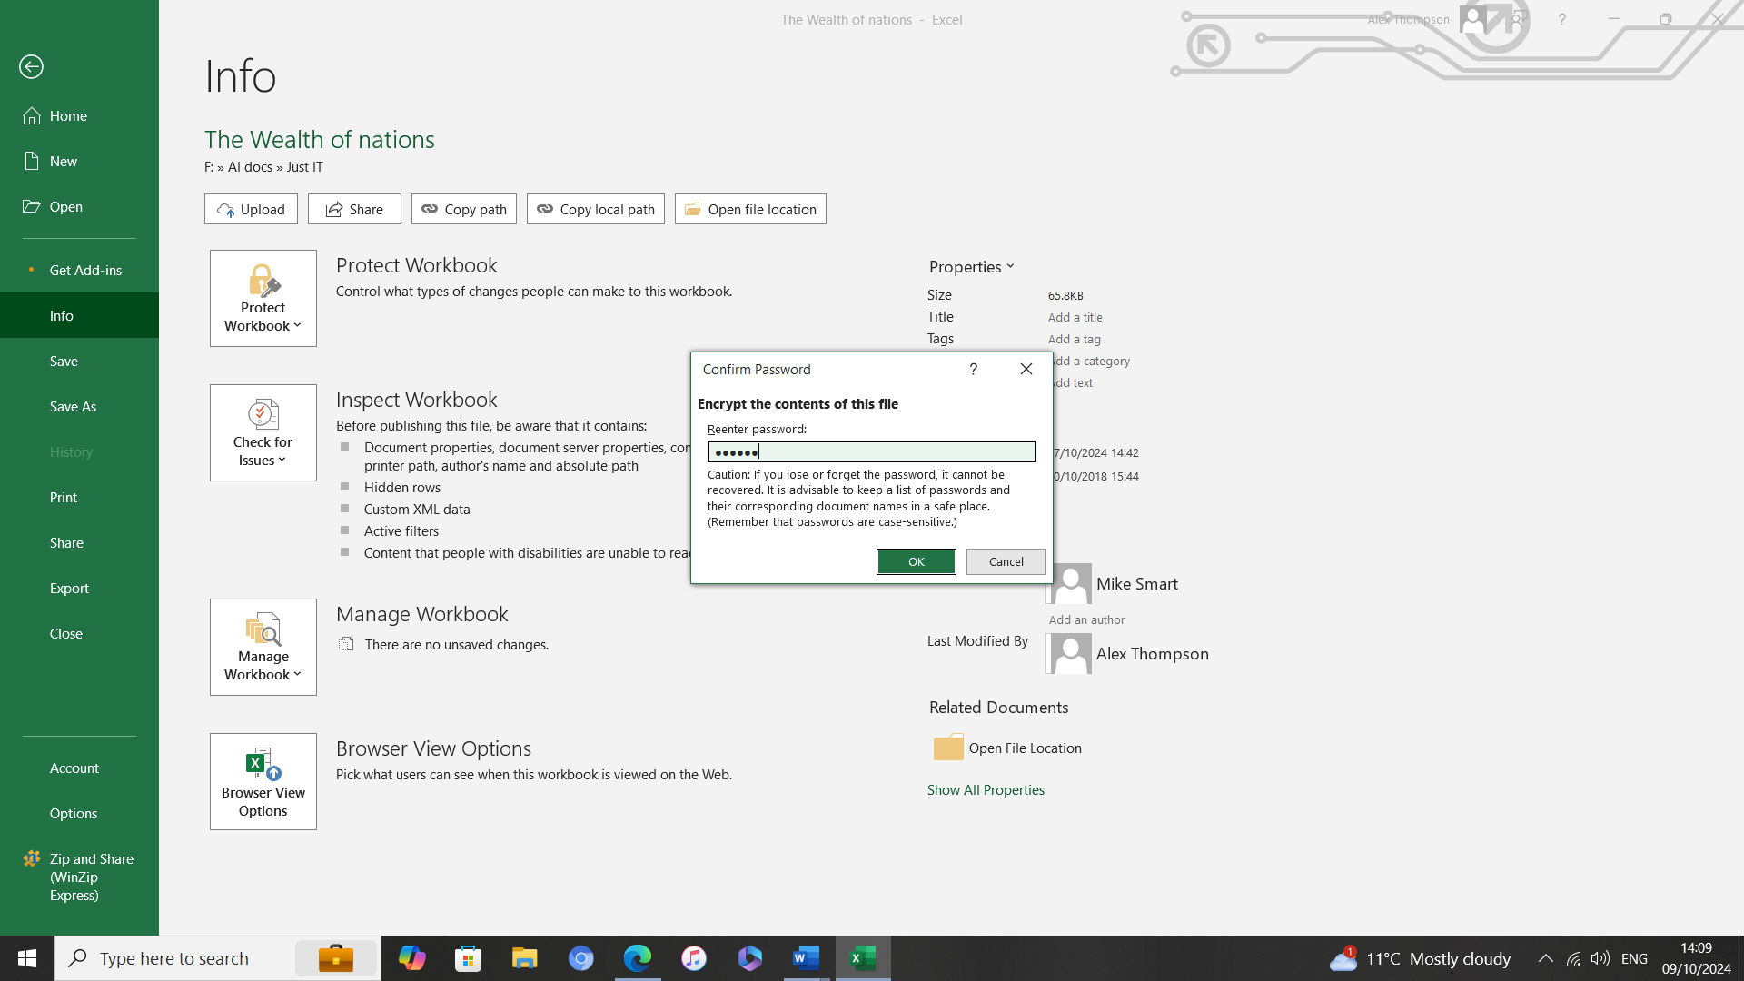

**GDP Tasks 2, 3 and 4**

* Column C has been converted to show the GDP – per capita in British Pounds Sterling (£)
* The sheet has been converted to a table
* A filter has been applied to only show information from 2019 (column D)

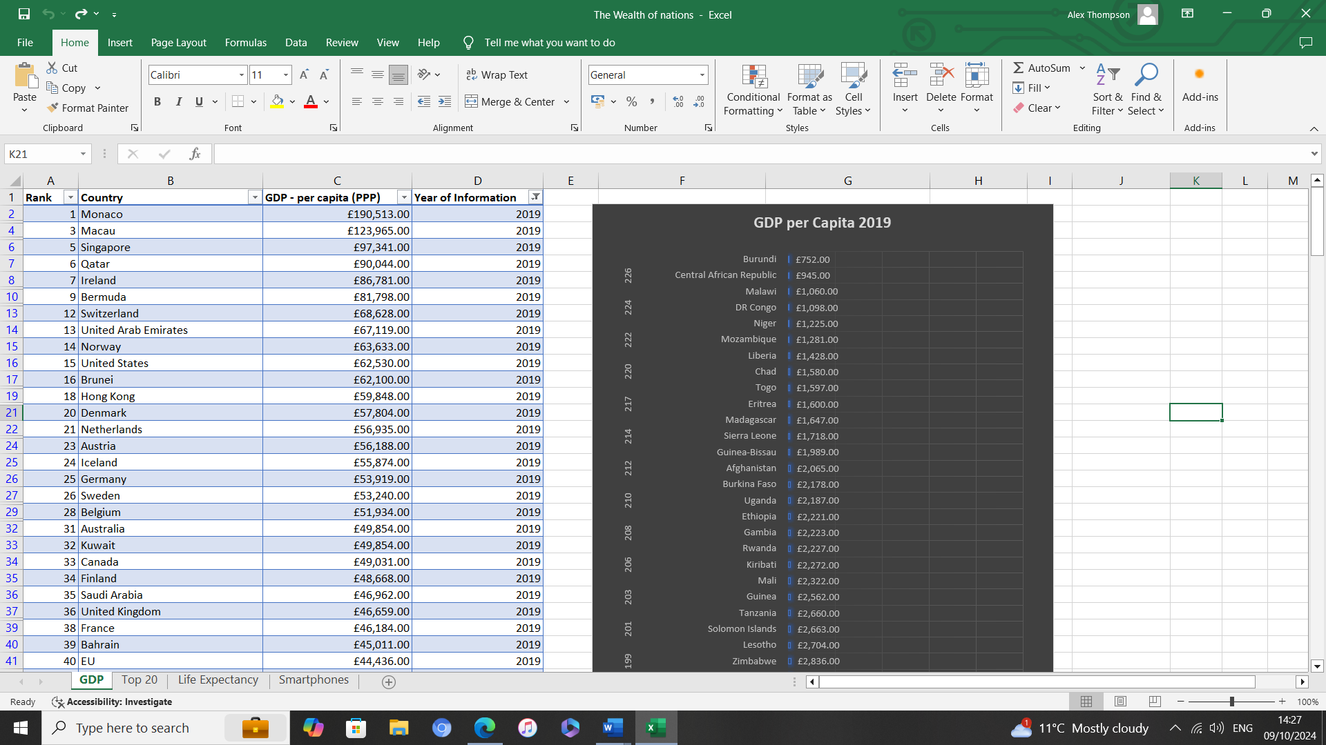

**GDP Tasks 5 - 10**

A new table and chart only including Rank, County and GDP. Edited to include a title, X and Y labels and be visually pleasing. Located on a new tab – Top 20.

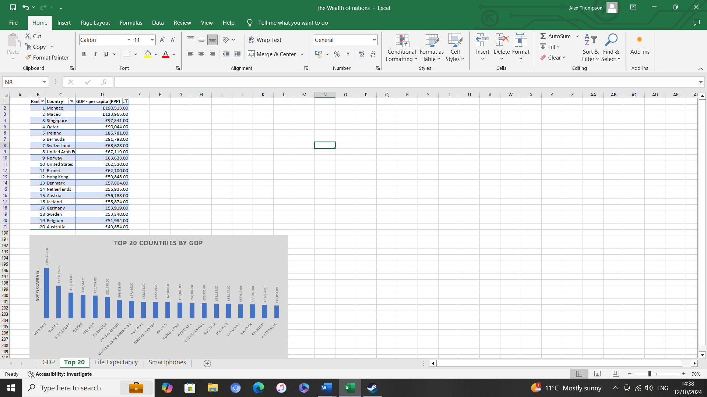

**Chart 1 – Top 20 Nations by GDP**

A bar chart showing the top 20 nations by GDP using the colour blind palette.

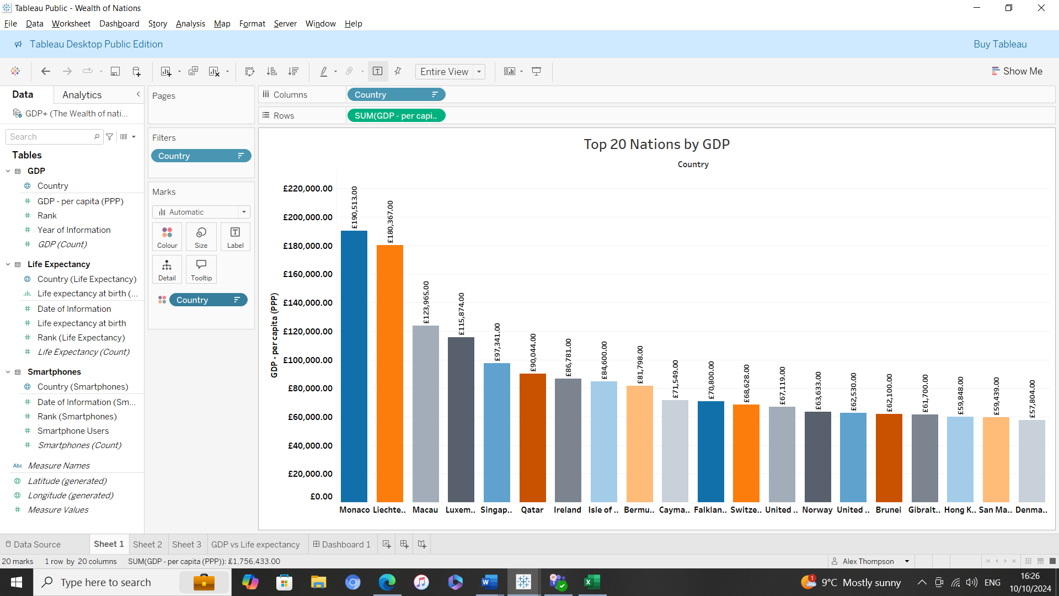

**Chart 2 – Top 20 Countries by Life Expectancy**

A tree map showing the top 20 nations by life expectancy.

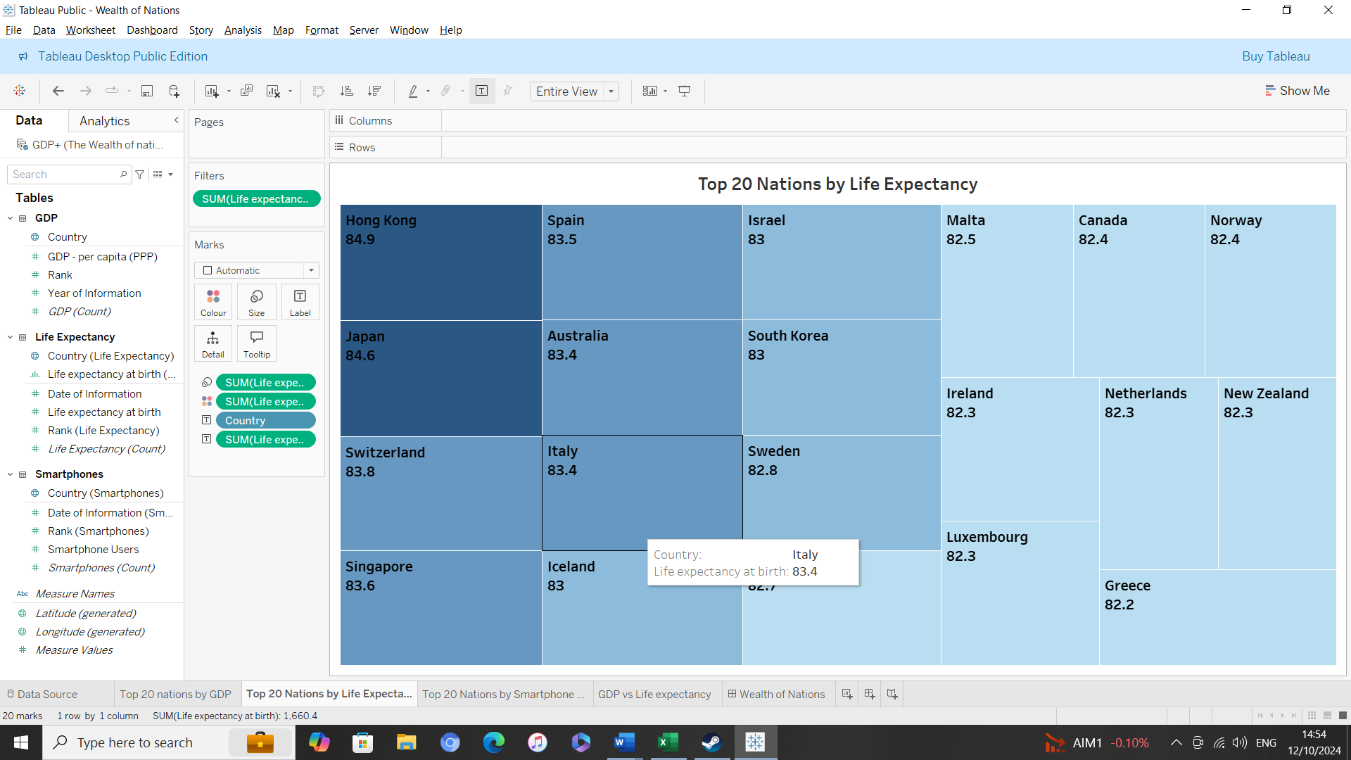

**Chart 3 – Top 20 Smartphone Users**

A World map showing the top 20 nations by smartphone users.

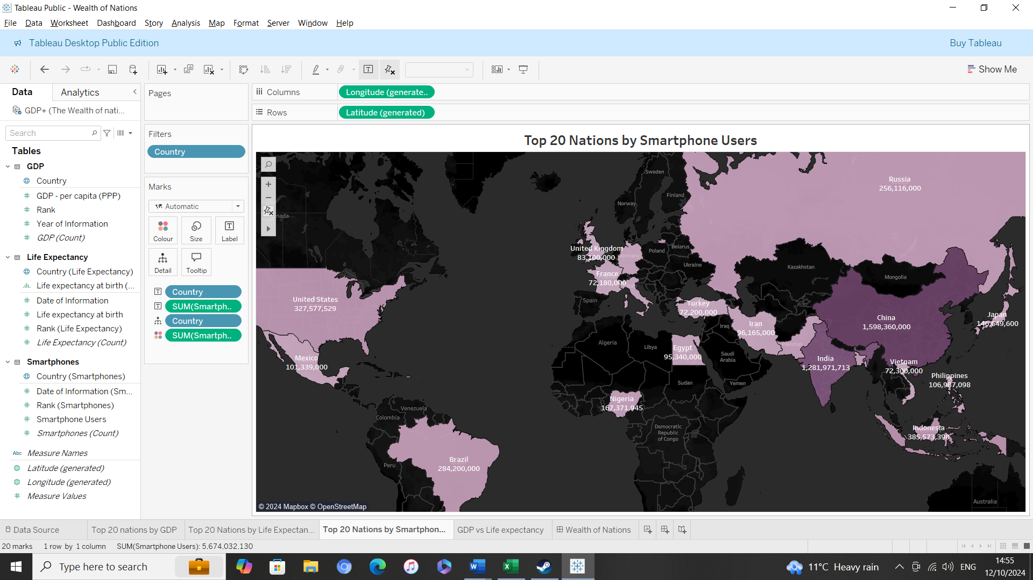

**Chart 4 – GDP vs Life Expectancy**

A scatter plot chart showing GDP vs life expectancy.

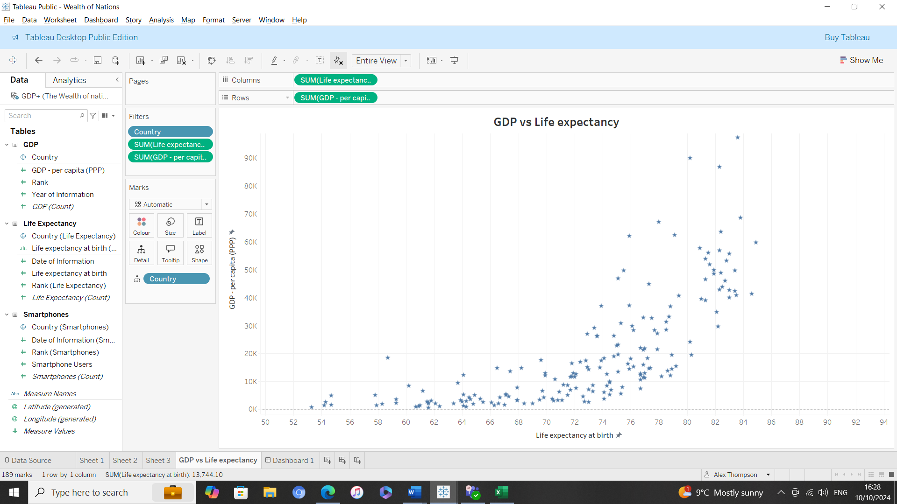

**Dashboard**

The dashboard showing all 4 charts

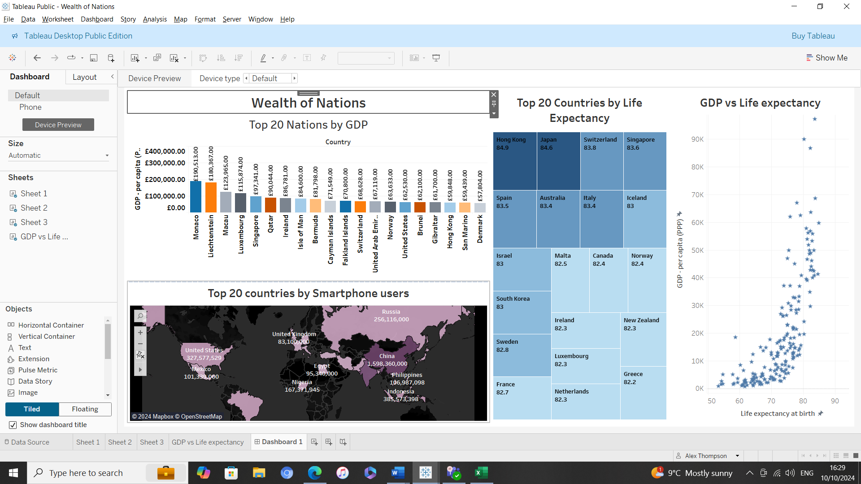

**Final Summary**

The excel portion of the assignment went fairly smoothly.

The Tableau section was fine for the first three charts. Although, since ‘Country’ is the only Dimension available to pair with the Measures, a Bar Chart would have been the most efficient method of display. However, I’ve used different charts for the sake of variety.

It took me a little longer to create the fourth chart as there wasn’t an obvious candidate. I experimented with a few different charts before settling on the GDP vs Life Expectancy scatter plot.